Dynamic Content: Archiving Women in the Arts
Outline of talk presented at the 2014 Archive-It Partner Meeting in Montgomery, AL

By Heather Slania

Director of the Betty Boyd Dettre Library and Research Center
National Museum of Women in the Arts

The Betty Boyd Dettre Library and Research Center at the National Museum of Women in the Arts (NMWA) is utilizing Archive-It to archive websites of new-media women artists. Like other art libraries, researchers come in to use materials like exhibition announcements, exhibition catalogues, and personal writing to write the history of artists and art movements. Today artists and galleries are using the internet to publish electronic exhibition announcements, electronic exhibition catalogues, and have personal websites and blogs which for the most part, are not be archived by arts organizations today.
NMWA started archiving websites in 2011 when an upcoming website redesign of nmwa.org allowed the opportunity to archive NMWA web properties as well as websites by pioneering new media artists. Women artists were at the forefront of the new media art and internet art movements—not capturing their websites would be a serious loss to art history and women’s history. New media artists who have done Internet-based art were chosen because their websites were one of the most important to save for future research. Additionally, NMWA doesn’t collect many of these artistic works due to the difficulties in trying to exhibit them.
Women artists are rarely recognized as being important or influential outside of a few exceptions like 18th century French painter Élisabeth Vigée LeBrun, 19th century American printmaker and painter Mary Cassatt, and 20th century Mexican painter Frida Kahlo. Today, 51% of artists are women but only 28% of solo exhibitions in major museums are by women. Women have also been left out of art historical texts. Only 27 women are represented in the current edition of Janson’s History of Art: in the editions until 1986 this number was zero. Through their artistic protest, the Guerrilla Girls helped showcase appalling statistics regarding women from the American art world. In 1989, 5% of artists in the Modern Art Sections were women, but 85% of the nudes were female. In 2005, only 3% of the artists were women and 83% of the nudes were female.
From the 16th-19th centuries, women were barred from studying the nude model, which formed the basis for academic training and representation. Becoming a well-regarded woman artist was extremely difficult. The ability for women artists to be a part of the art historical cannon increased as modernism began and today some of the most well regarded artists are women. Part of the museum’s mission is to bring to light remarkable women artists of the past the other is to promote the best women artists working today. The purpose of NMWA’s Contemporary Women Artists on the Web collection is to support art historical research of this group of innovate women artists.
The first batch of artists were collected from the books Internet Art by Rachel Greene and Digital Visions: Computers and Art by Cynthia Goodman. While new media art is a large category, I started with a narrower scope of those that were working with digital or internet art. At first, gallery website sections were also included but have since been removed from active collecting. In addition, major organizations and groups related to women artists are included. The artist’s websites fit into two general categories as either art itslef or they are the artist’s electronic CV often containing representations or still images of the works.
Many people wrongly believe that the Internet Archive is capturing all necessary information, but that was quickly not found to be the case. Jenny Holzer’s website is a good example of this. NMWA encountered typical issues such as trying to archive databases and scope around crawler traps, but the biggest problem is that artists like to be cutting edge and standards and usability are not their biggest concern with making art. It’s about making a statement. Artists will always be ahead of the curve, so these websites might always be difficult to capture.
The title of this talk, Dynamic Content, refers to the rich material that future art historians will find when they utilize these archived resources but also the type of content that is typically found on these websites. Some websites, like that of digital and video art pioneer Lynn Hershman-Leeson, were impossible to capture at first. In that case, with Archive-It’s help, NMWA was able to archive an image directory and blog but it does not capture the animation and interactivity of her original website. Since the project first started, Hershman-Leeson now has a redesigned website that can be archived with her old website lost to history. Hershman-Leeson’s website archiving problems were extreme, but they were not unusual.
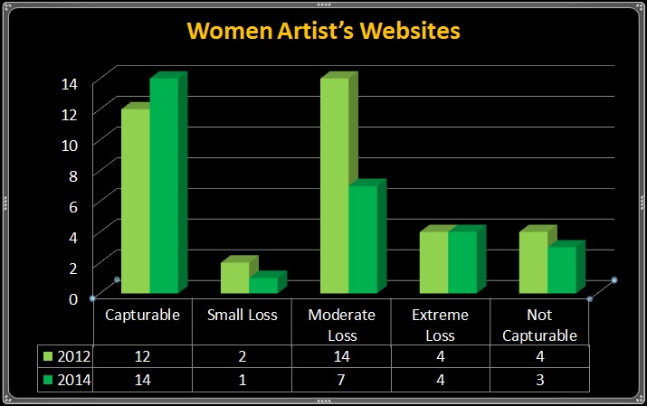
In 2012, 61% of the collection’s websites had moderate loss, extreme loss, or were not capturable. This went down to 48% in 2014; however several websites that were first included in the 2012 project are no longer online. The 3-5 year half-life found for academic journal citations looks like it might be true for art-based websites as well. Also, website redesigns can turn websites with moderate loss into ones that are not capturable. Vimeo is used frequently by artists which accounts for much of the websites in the moderate to extreme loss categories. Despite the issues that Vimeo and YouTube have with being archived, the Contemporary Women Artists on the Web Collection has already captured 6,686 videos within the small collection.
Sometimes individuals find it hard to take internet-based art seriously. As Steve Dietz, founding Director of New Media Initiatives at the Walker Art Center, wrote
… in general, the older an artifact is, the more it acquires a certain aura of great interest, if not necessarily greatness. Prehistoric footprints are an amazing find, while the once reviled Baroque painting is now eagerly collected and even Norman Rockwell, with the passage of time, becomes acceptable subject matter for a serious museum show. With net art, this does not presently seem to be the case. The time frame is always the next five minutes, and historical art--art that is older than 5 minutes--more often seems outdated than historic. That is, if you can find it or it works with current configurations of hardware and software.
Another issue that comes up often with art works is artist’s intent. Often artists pick different mediums because they are considered ephemeral. So do artists intend for these websites to be ephemeral and not saved because they are on the web? They may, but there is a long history of trying to document ephemeral art pieces in libraries and museums. Additionally these are important research documents for the future. However, if an artist does not want their website archived, they can opt-out. Copyright is a concern in the art world and some galleries and artists can be very litigious. However with the vast amount of court cases showing that archiving is transformative, it illustrates that institutions do not have to ask for permission before archiving. However, it is polite to allow artists to opt-out, particularly if they want it to just be ephemeral.
Outside of the nuts and bolts and legal and philosophical issues, time is a factor for all web-archiving programs, especially those at small institutions like NMWA. However, this is information that is being lost every day and should be considered a high priority at any institution. It may mean that not every crawl is perfected, but it will mean that the institution is saving some history that would otherwise not be saved.
Small institutions can and should take part in web-archiving. Archiving at a small institution is possible if the collection is focused enough. Starting it small and growing it over time is ideal. Small institutions thinking about web-archiving need to find the right time such as an anniversary or some other commemorative event to propose a web-archiving project. Start by offering to archive the institution’s web properties and have a proposal for a small project that fits within the institutional mission. It is easier to grow a small project than to build one out later. Large organizations cannot do it all so it’s critical to find ways that smaller, less tech savvy organizations to can help save contemporary history.
The web-archiving efforts at NMWA will continue to grow in the future. First, the new media collection will expand to include video and performance artists. Secondly, a web-comics by women collection will be started. This will likely occur in November 2015.
More arts organizations must begin to do web-archiving outside of their own websites. The ARLIS/NA Artist Files Special Interest Group is beginning to talk about how to manifest large-scale collaboration between institutions, but this process is in its infancy. Collaborative collection development will be necessary for success. In order to collaborate, individual collections will need to be searchable from one place, ideally with more structured metadata to help create connections between these collections.
Artists and their web designers need to be educated about web-archiving and the difficulties that dynamic content presents. This is not to constrain them, but so they are aware of their choices going forward.
Art-related content is particularly vulnerable. Artists will always use the web in new and interesting ways. The only way we can archive culture and save the present for the future is to collaborate.

Tracy Seneca, “The Web-at-Risk at Three: Overview of an NDIIPP Web Archiving Initiative,” Library Trends 57, no. 3 (Winter 2009): 428.

